|  |  |  |  |  |  |
| --- | --- | --- | --- | --- | --- |
| Date | 25-Nov-22 | | | Tester Name | Mayuri Patel |
| Environment | Penfax - Test | | | Login used |  |
| Operating System | Select OS | Version: | Update: | | |
| Software Used | Select Software | Version: | Update: | | |
| Select Software | Version: | Update: | | |
| Release version | 22.4.1 | | | | |
| Title | Add a new organization | | | | |
| Test Type | Regression | | | | |
| Test Scenario | Create a New Employer | | | | |
|  |  | | | | |
| Expected Results |  | | | | |
| Pass/Fail | Pass | | | JIRA# | N/A |

Describe your steps with screenshots:

Open Organization search

Add Organization

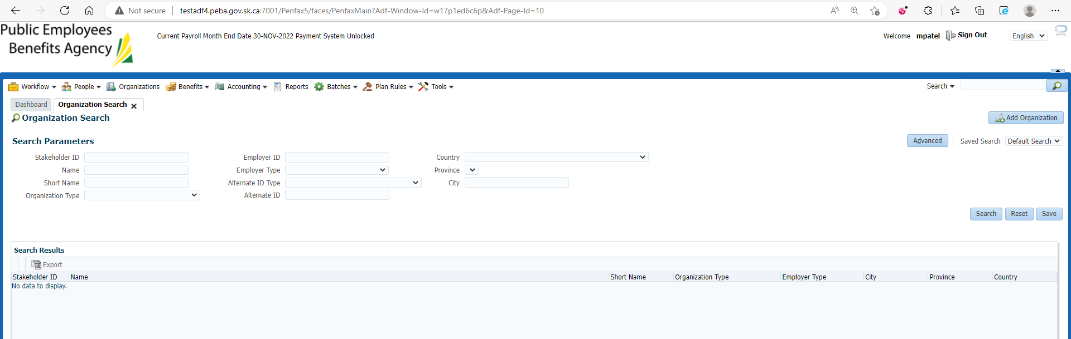

Enter Organization Type🡪Employer,

Employer type🡪Employer

Employer ID🡪 4-digit employer Code

Name🡪 Name of it

Hit save on the top right corner

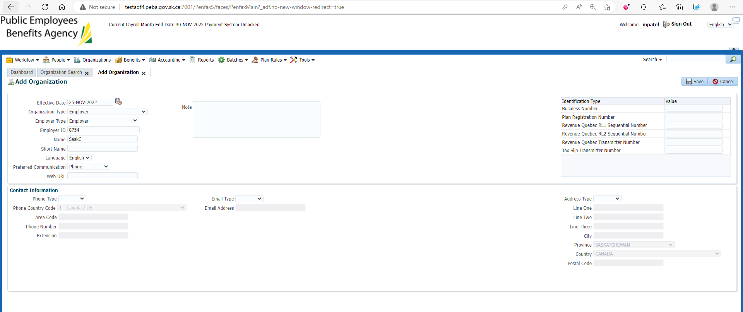

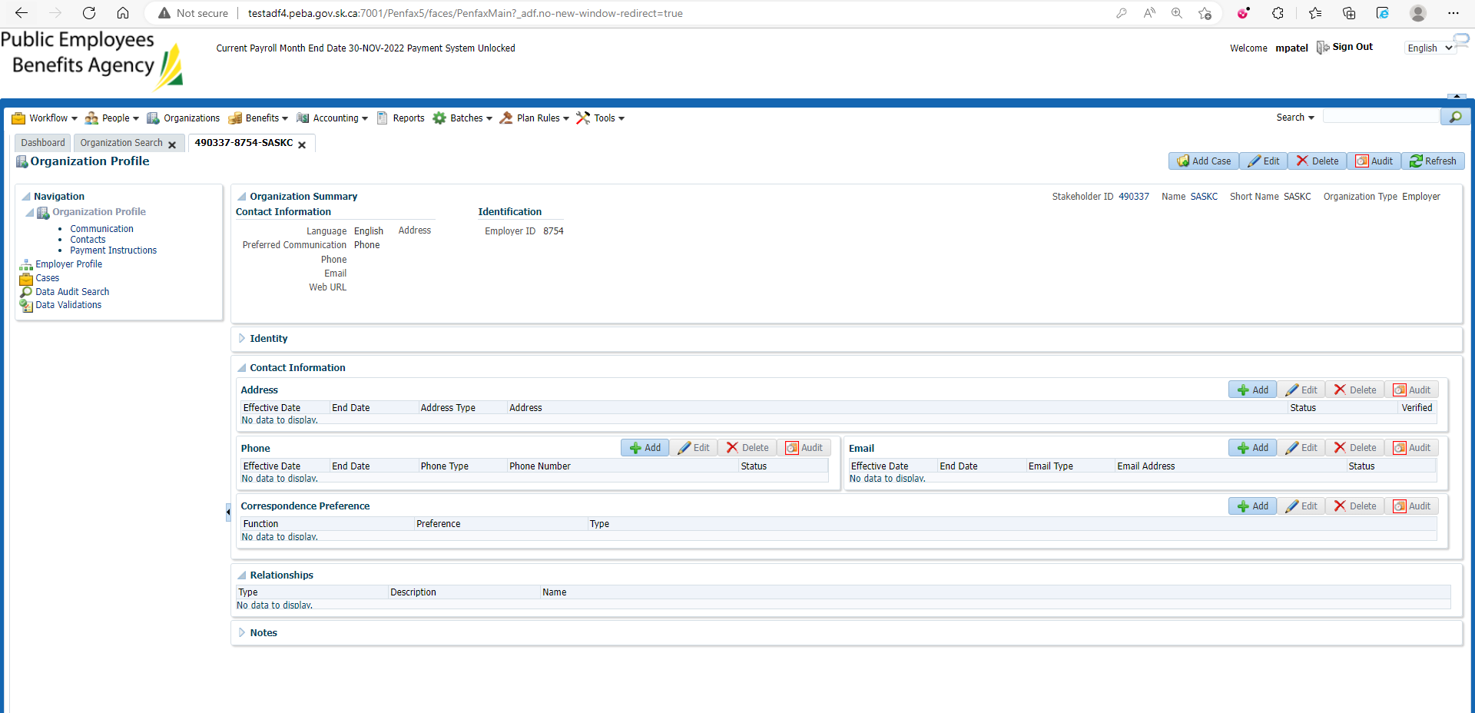

Under Organization Profile 🡪Contact Information🡪 Correspondence Preference

Hit Add Correspondence Preference

Enter details and Save

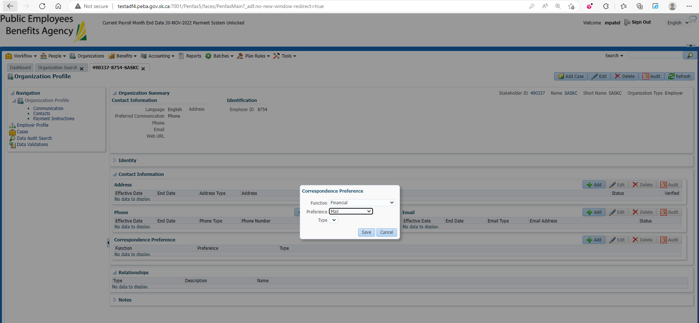

Details are reflected

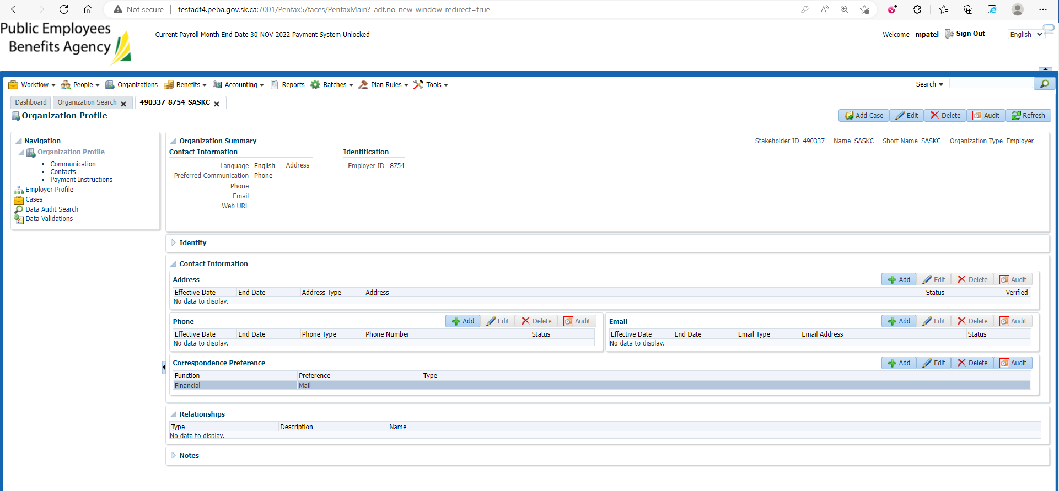

Under Contacts, Add Contacts

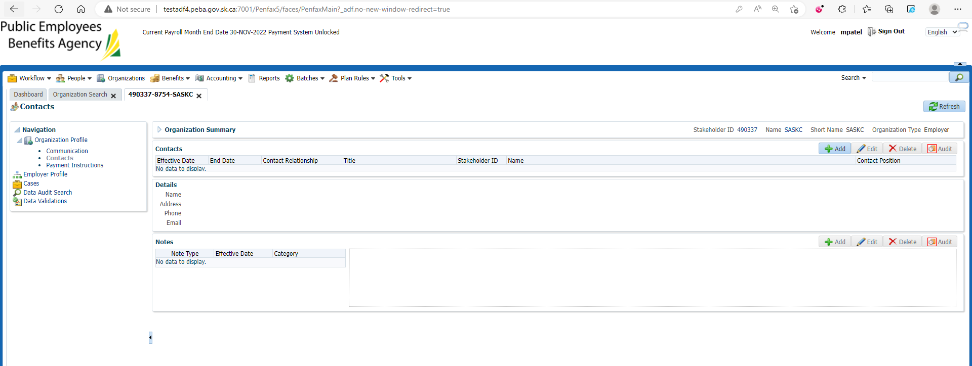

Enter person first name, last name and effective date and save

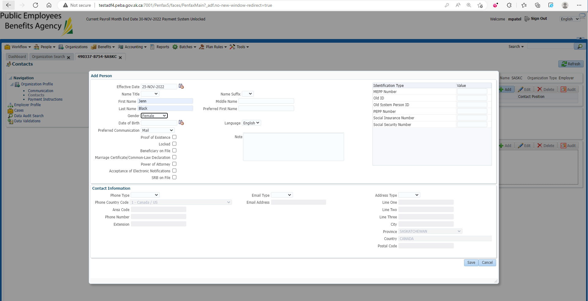

Enter Relationship🡪 Primary, Contact Position🡪Administrator and save

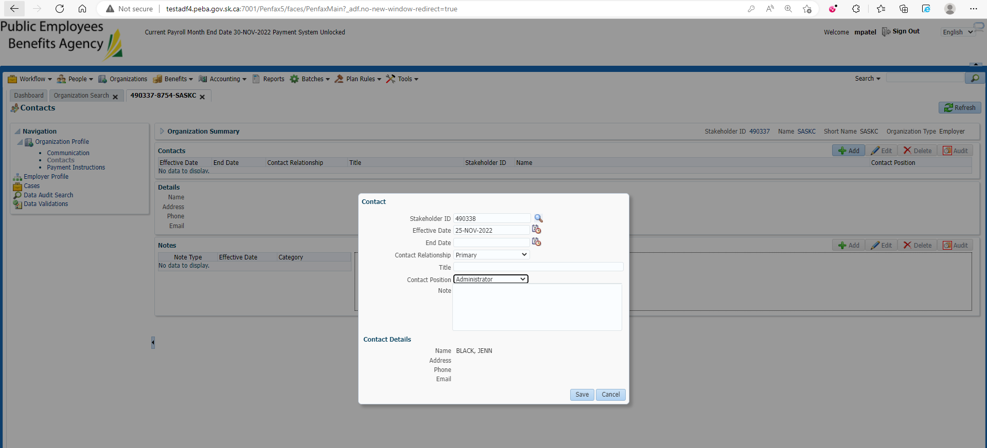

Changes are saved and reflected

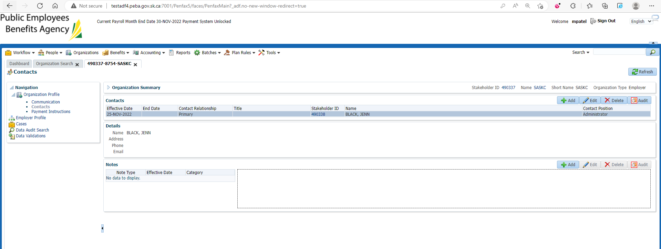

Under Employer Profile 🡪 Plan Affiliation

Add Plan Affiliation

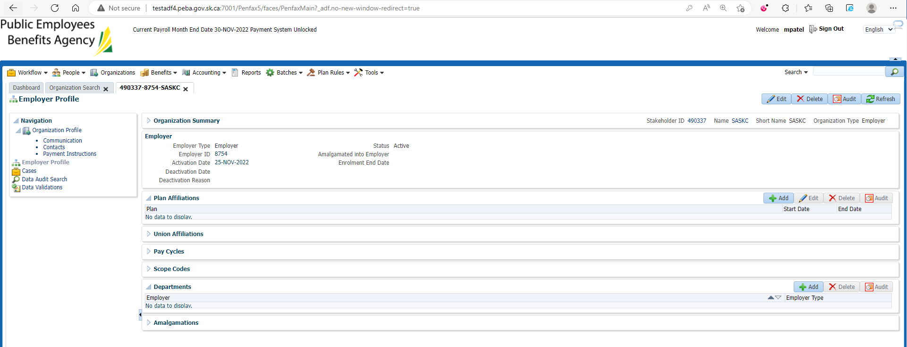

Enter Plan🡪MEPP, start date and save

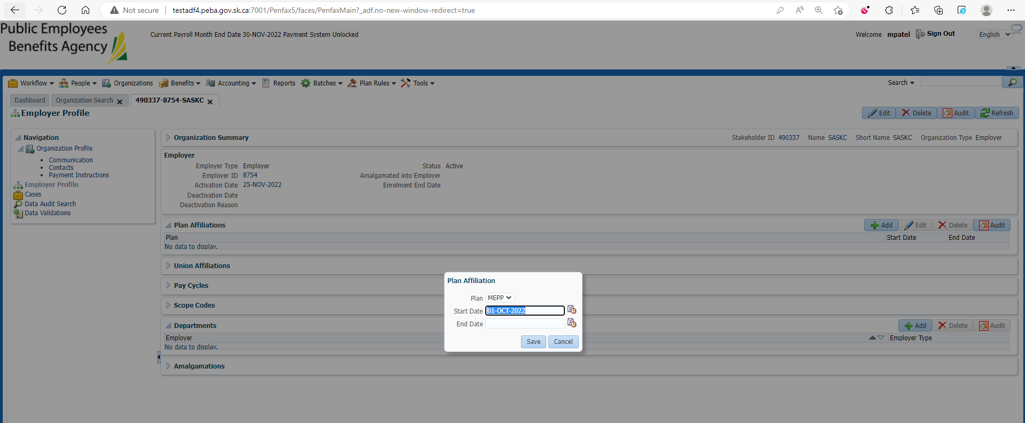

Changes are reflected

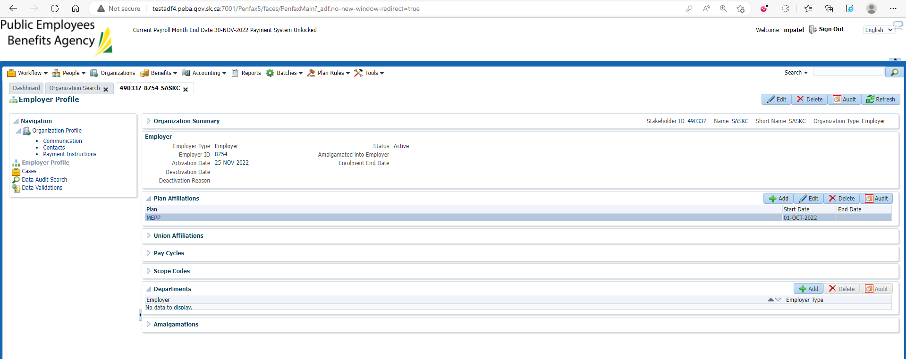

Under Employer Profile 🡪 Pay Cycle

Add Pay Cycle

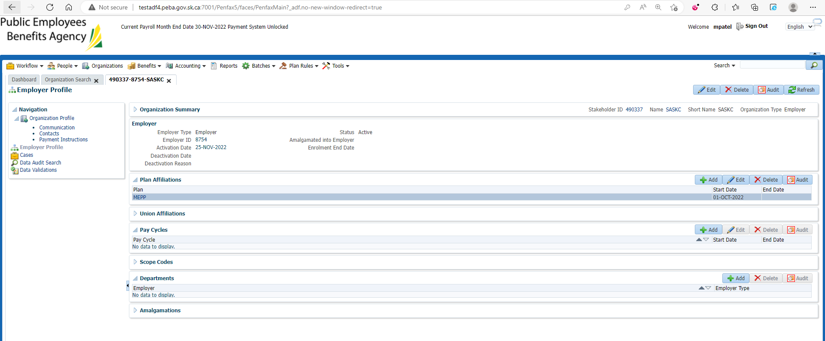

Enter Pay Cycle🡪Monthly, start date and save

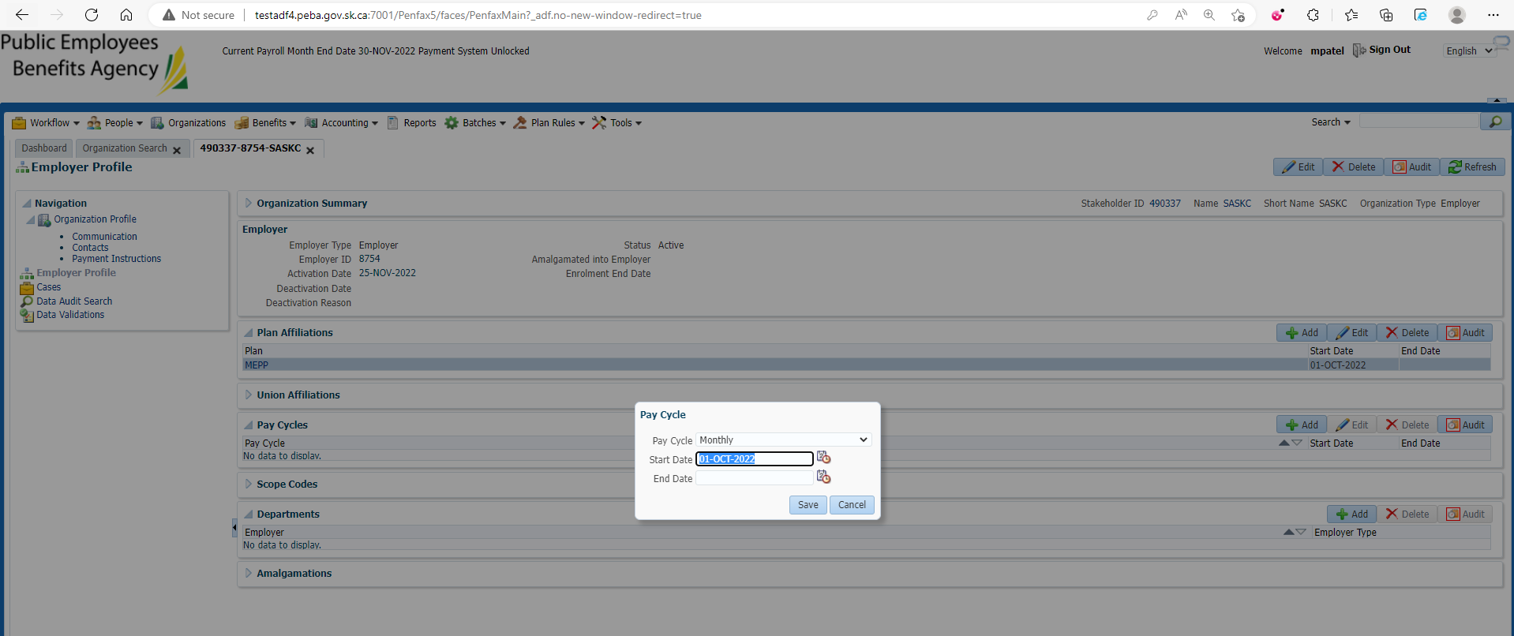

Changes are reflected

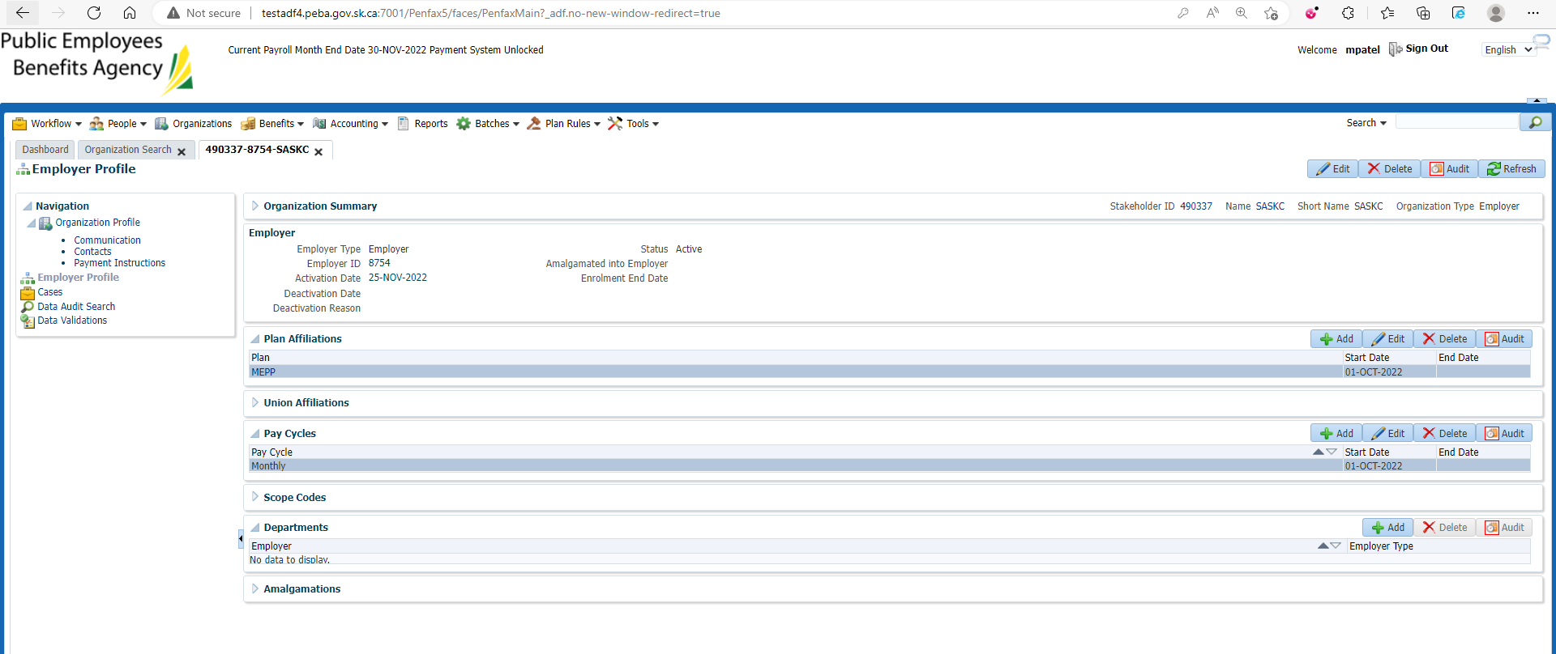

Under Employer Profile 🡪 Scope Codes

Add Scope Code

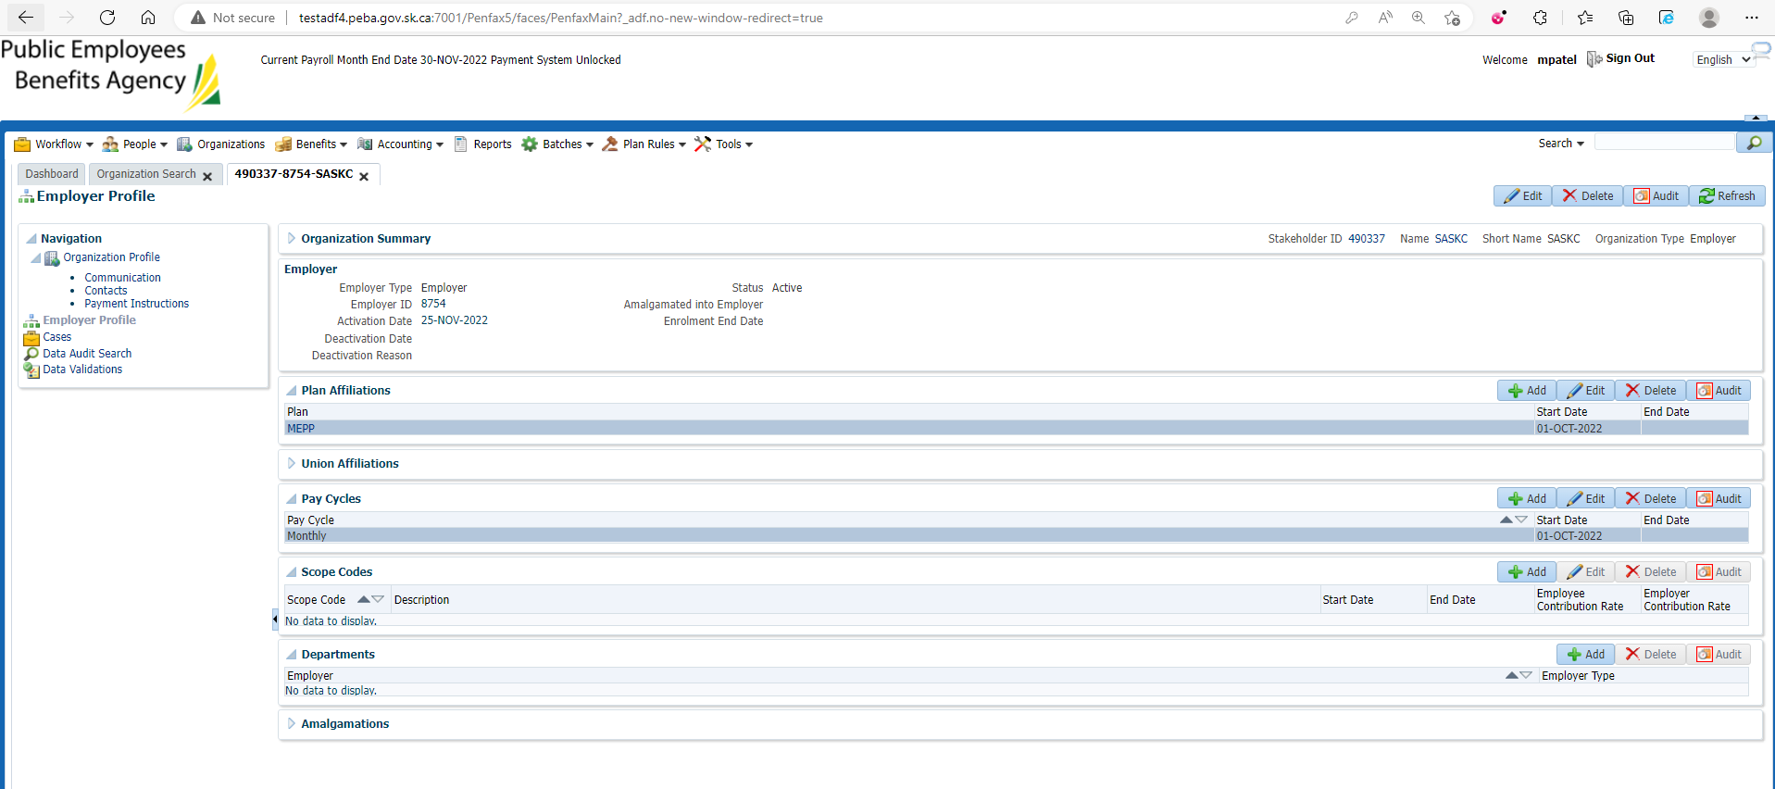

Enter Scope Code🡪IS, Description🡪In Scope, Start Date, Employer and Employee Contribution Rate and save

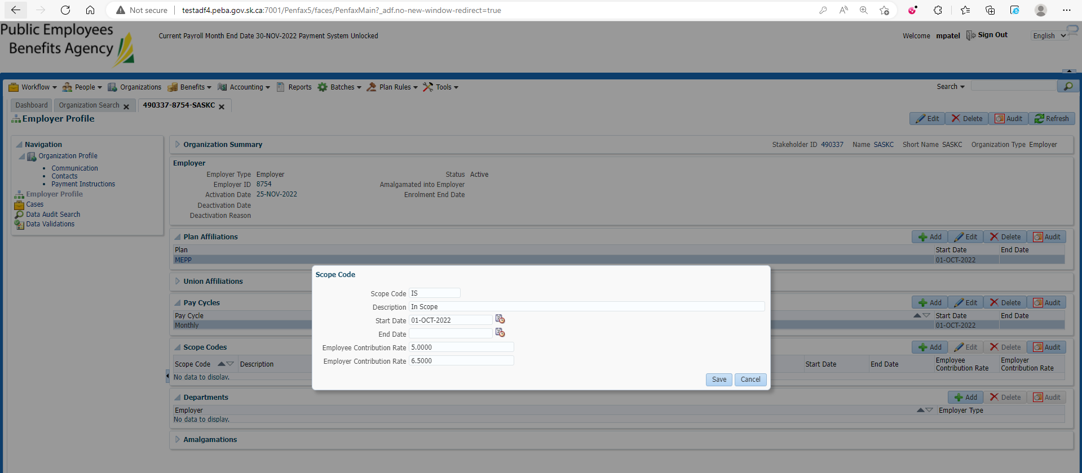

Changes are there

